**INFO 6205**

**Program Structures & Algorithms**

**Fall 2020**

**Assignment No**

* **Task**
* **Output** (few outputs to prove relationship)
* **Relationship conclusion**
* **Evidence to support relationship** (screen shot and/or graph and/or spreadsheet)
* **Screenshot of Unit test passing**

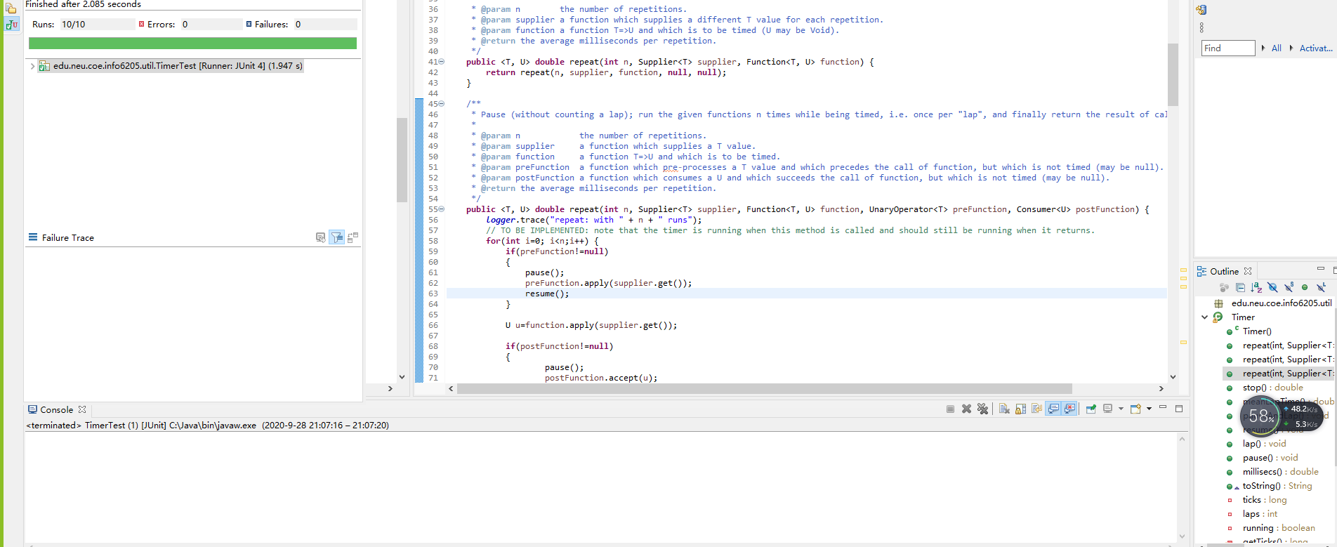

**This picture is proof of my program's success.**

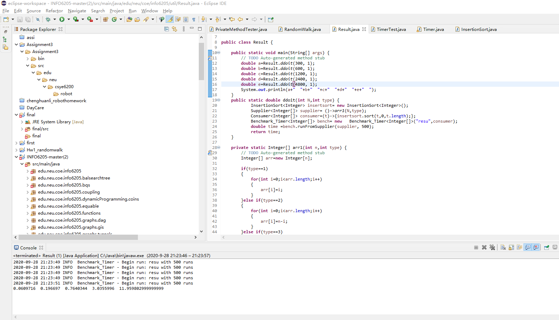 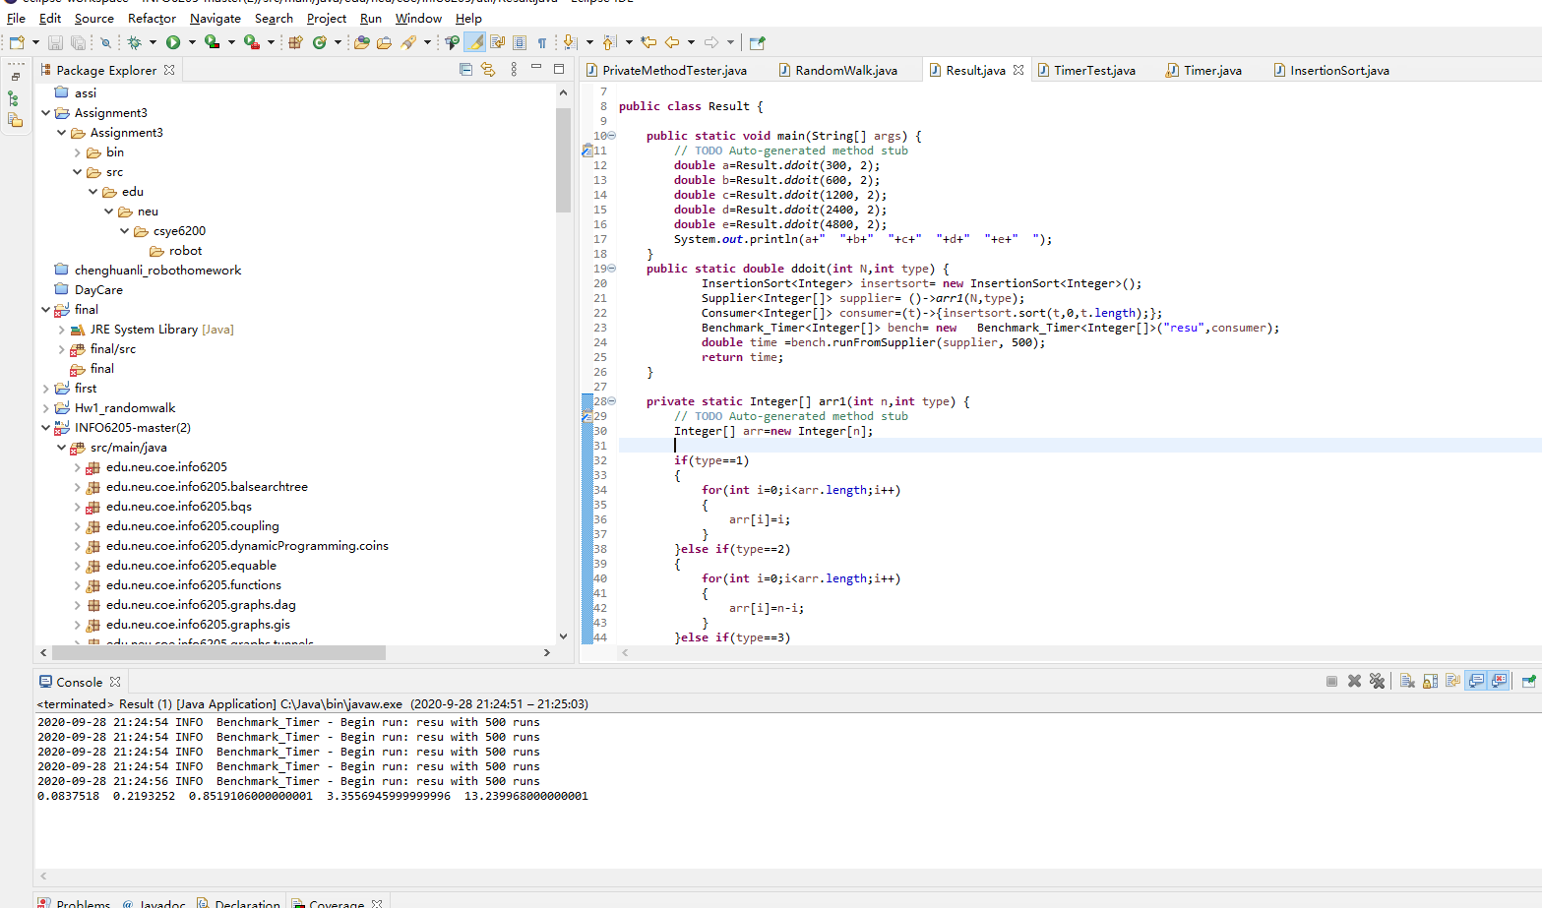 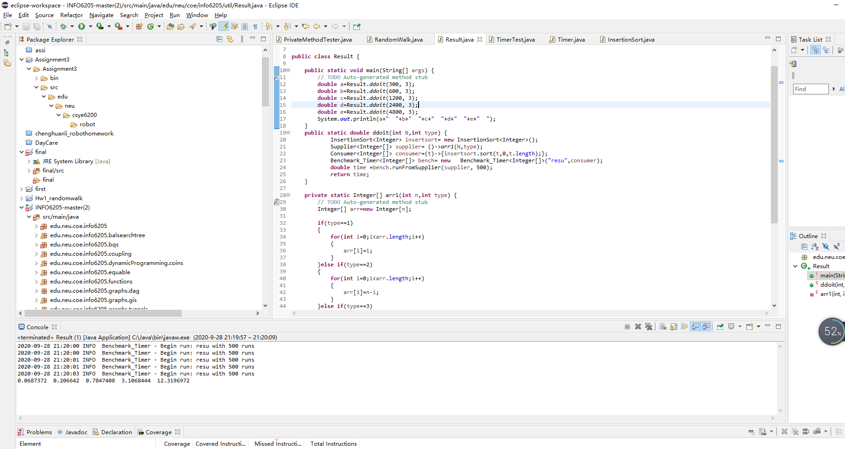 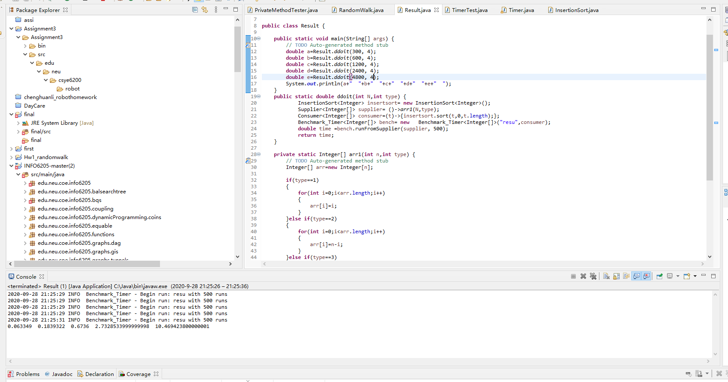

**I set the value of N to 300,600,1200,24,4800, then ran the program and took a screenshot of the result.**

**Then I'll tabulate the data I get.**

|  |  |  |
| --- | --- | --- |
| type | N | time |
| 1 | 300 | 0.06 |
|  | 600 | 0.19 |
|  | 1200 | 0.76 |
|  | 2400 | 3.03 |
|  | 4800 | 11.95 |
| 2 | 300 | 0.08 |
|  | 600 | 0.21 |
|  | 1200 | 0.85 |
|  | 2400 | 3.35 |
|  | 4800 | 13.23 |
| 3 | 300 | 0.06 |
|  | 600 | 0.2 |
|  | 1200 | 0.78 |
|  | 2400 | 3.1 |
|  | 4800 | 12.31 |
| 4 | 300 | 0.06 |
|  | 600 | 0.18 |
|  | 1200 | 0.67 |
|  | 2400 | 2.73 |
|  | 4800 | 10.46 |

**Both from the data and from the image of the whole program run more regular. And, since I've multiplied each N by a factor of two, I can look at the corresponding time and see a factor of four.**

**So, I think that (N1/N2) ²≈ Time1/Time2.**